HOME PAGE BANNER:
Billing Update: Your new bill may include an adjustment. We understand that an unexpected change to your bill can be confusing, and we want to help answer your questions. Please read more about what happened and how we can help →
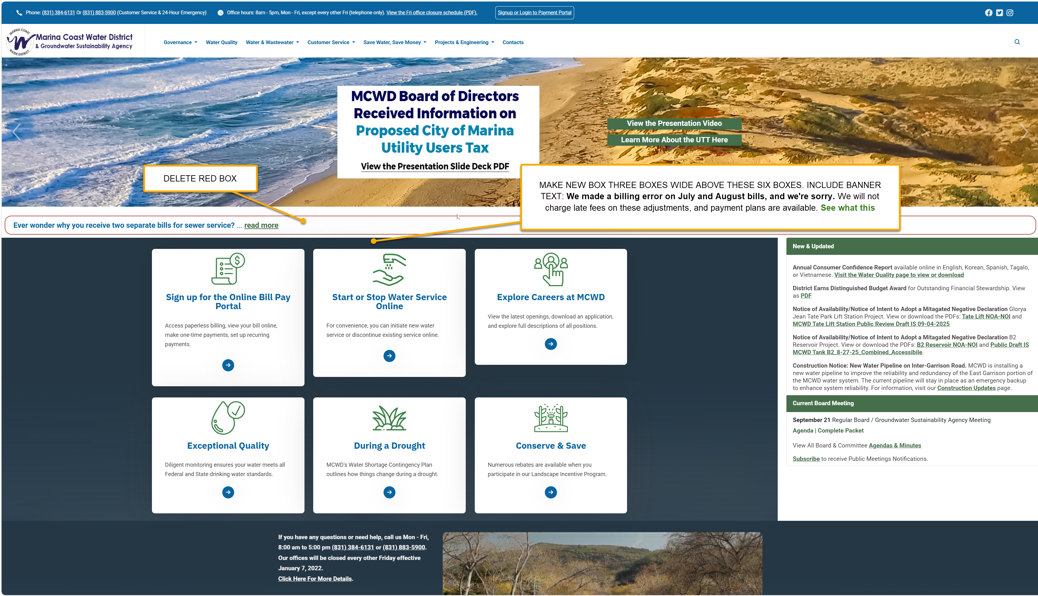

THIS GOES AT THE TOP OF THIS PAGE ABOVE ALL ELSE:
Billing Adjustment for July and August 2026
Thank you for your patience as we complete these billing adjustments. We understand that an unexpected change to your bill can be concerning, and we want to explain what happened and how we can help.
We sincerely apologize for an error in your bills for July and August 2026. The approved rates effective July 1, 2026 were not applied correctly, resulting in incorrect charges to your account.
We have corrected the billing rates in our system and recalculated the affected charges. The adjustment will appear on your next billing statement and covers only the difference between the original charges and the charges under the approved rates.
The summary included with your notification letter shows the original and corrected amounts for each affected service and billing period, along with the total adjustment for your account. Your statement may arrive before your letter.
Late fees have been suspended while the District completes these billing adjustments.
If you are experiencing financial hardship and need assistance, please do not hesitate to contact us. We are here to help.
We take responsibility for this error and appreciate your patience as we correct it.
If you have questions or would like help reviewing your bill, please contact Customer Service at 831-384-6131, email customerservice@mcwd.org, or visit our District office at 920 Second Avenue, Marina.

Frequently Asked Questions
Why does my bill include an adjustment?
We made an error when applying the approved water and sewer rates that took effect July 1, 2026. Affected July and August bills used the previous rates, resulting in undercharges.
What does the adjustment cover?
It covers only the difference between your original charges and the charges under the approved rates for the affected billing periods.
Is this another rate increase?
No. This correction applies the rates that were already approved and effective July 1, 2026.
How can I check the amount for my account?
The summary included with your notification letter shows your original charges, corrected charges, and total adjustment.

Why did I receive my bill before my letter?
Bills and notification letters are sent separately, so your October statement may arrive before the letter explaining the correction.
Will I be charged late fees?
Late fees have been suspended while the District completes these billing adjustments.
What if I cannot pay the amount all at once?
Payment plans are available upon request. If this unexpected charge creates a financial hardship, our Customer Service team can discuss payment arrangements with you.
What has the District done to correct the error?
We have corrected the billing rates in the system and recalculated the affected charges.
Why did water and sewer rates increase?
The new rates help cover the costs of providing water and sewer service, maintaining District facilities, and replacing aging infrastructure. They took effect July 1, 2026. You can review the current rates and information about the increase.
- Ord Community
- Marina
- Recycled Water
Is this adjustment related to proposed Marina’s Utility Users Tax (UUT)?
No. This adjustment corrects water and sewer charges for affected July and August 2026 bills using the approved rates effective July 1, 2026.
Who can help if I still have questions?
Please contact Customer Service at (831) 384-6131 or (831) 883-5900, email customerservice@mcwd.org, or visit our District office at 920 Second Avenue, Marina, CA 93933. We can help review your summary, explain the amount on your bill, and discuss payment options.

